**SPREADSHEET PROJECT: ZOMATO RESTAURANTS**

**Objective questions**

1. What is the total no. of tables present in the data?

**Ans:** There are **2 tables** in the data **(Raw data & Country description)**

1. What is the total no. of attributes present in the data?

**Ans:** There are **22 attributes** present in the data **(20 in Raw Data and 2 in Country Description)**

1. How many categorical columns are there in the data? [Search about categorical and continuous data, and try to answer this question]

**Ans:** Categorical data in excel refers to data that can be sorted into categories or groups, where each value belongs to one of a limited number of distinct categories.

There are **14 categorical columns** in the data.

1. The data consists of some inconsistent and missing values so ensure that the data used for further analysis is cleaned.

**Ans:**

1. Changed city names to **“Sao Paulo” (60 Replacements)** and **“Istanbul” (42 Replacements)** using **Find & Replace tool.**
2. In **Restaurant names column** Replaced special character **“í©” to “e”** , Removed special character **“#”** , Removed **“Û±”** .
3. In **Datekey Opening column**, Replaced **underscores with “ – “** and **converted the format to date.**
4. There are **missing values in Cuisines column** where country is America. So the missing values are **replaced with “American cuisine” which is most common in USA**.
5. Using the LookUp functions, fill up the countries in the original data using the country code.

**Ans:** Here new column is created with the named as **“Country Name”** and the values are filled with the help of the **country description sheet** **using IFNA and VLOOKUP Function**.

**Formula:**

**=IFNA(VLOOKUP(C2,'country description'!$A$2:$B$16,2,0),"Country not available")**

1. Create a table to represent the number of restaurants opened in each country.

**Ans:** Created a pivot table of number of restaurants opened in each country where : **India** have the highest count of restaurants with **8652** and Canada with the **smallest** with **5**.

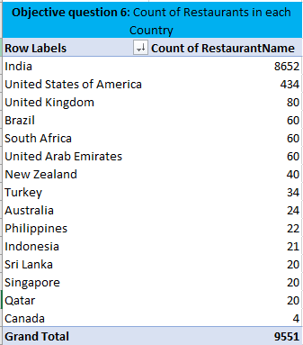

1. Also, the management wants to look at the number of restaurants opened each year, so provide them with something here

**Ans: Used Text to Columns feature** to **create a column** named **“Year of opening”** and created a pivot table for number of restaurants opened each year. In the year **2018** the number of restaurants opened are **high** and in the year **2012** the number of restaurants opened are **low**.

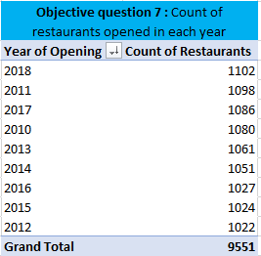

1. What is the total number of restaurants in India in the price range of 4?

**Ans: 388**

The total number of restaurants in India of price range 4 is calculated using the **countifs function**.

Formula: **=COUNTIFS('Cleaned Data'!Q2:Q9552,'Cleaned Data'!T8712,'Cleaned Data'!E2:E9552,'Cleaned Data'!E3)**



1. What is the average number of voters for the restaurants in each country according to the data?

**Ans:** The average number of voters in each country is found using a pivot table.

Here the **highest votes** in country is **Indonesia** with **772 average votes** and **lowest** is **Brazil** with **19 average votes.**

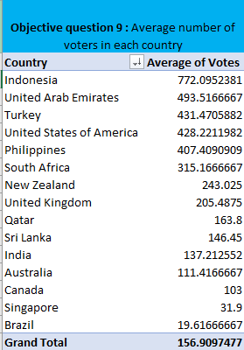

1. Calculate the average rating for all the restaurants that have price_range < 4 and provide online delivery. Use only the “IF” function, Logical Operators, and Aggregation functions to solve this problem. **[Note: Don’t use Conditional aggregation in this question.]**

**Ans: 3.27381151**

We use array formula to find the average rating for price range < 4 and provide online delivery.

Formula :  **{=AVERAGE(IF(('Cleaned Data'!$Q:$Q<4)*('Cleaned Data'!$N:$N="Yes"),'Cleaned Data'!T:T))**



1. Using Conditional formatting highlight the rows of restaurants that are located in the countries or cities that you’ve suggested to the management for opening new restaurants.

**Ans:** After analysing conditional formatting has been applied to the “cleaned data” sheet.

Countries with a lower restaurant count and a relatively low average rating indicate a market with potential for new restaurants. Based on the provided dataset, the countries mentioned below are considered:

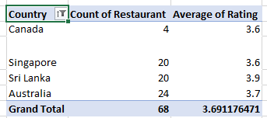

1. Create a new customized price column that consists of the abbreviation/symbol of the currency along with the Average_cost_for_two value. [Use string operations to do this task]

**Ans:** A new column is created for this named “Price in each country” in which average cost is shown along with the country currency symbol.

**MID** and **FIND Functions** are used here

Formula : **=MID(L2,FIND("(",L2,1)+1,FIND(")",L2,1)-FIND("(",L2,1)-1)&" "&S2**

1. How can you create an array formula in Excel or Google Sheets to count the number of restaurants listed that do not offer online delivery, are in the lowest price range, and have an average cost for two people less than or equal to 250 Indian Rupees?

**Ans: 1694**

By using **array formula** we can find the solution

Formula : {=COUNTIFS('Cleaned Data'!N2:N9552,"No",'Cleaned Data'!Q2:Q9552,1,'Cleaned Data'!X2:X9552, "<=250.00")}

**Subjective questions**

1. Suggest a few countries where the team can open newer restaurants with lesser competition. Which visualization/technique will you use here to justify the suggestions?

**Ans: Analytical approach:** Created a pivot table with country names as rows and used the average rating and Restaurant count as field values. After applying filters to focus on countries with and average rating below 4 and a low number of restaurants, we can identify 4 locations where the team could consider opening new restaurants.

**Inferences:** The selection of countries for potential expansion is based on thorough analysis, targeting regions with both low competition and average ratings below 4. This strategy aims to identify areas where entering the market could offer significant opportunities for growth.

**Visualization : Line with marker**

**Suggested countries to open newer restaurants:**

* Canada
* Singapore
* Sri Lanka
* Australia

**Location :** Excel file – sheet name – Subjective question 1 & 2 Table - Countries where the team can open newer restaurants with lesser competition.

1. Come up with the names of States and cities in the suggested countries suitable for opening restaurants.

**Ans: Analytical Approach:** Used a pivot table with country name and city as rows, and included average rating and count of Restaurant Ids as field values. Then applied filters to focus on specific countries and cities with both low restaurants and low ratings.

**Inferences and Recommendations:** On viewing the pivot table, the suggested cities for opening a new restaurant are:

* **Australia:** Armidale, Balingup, Dicky Beach, Flaxton, Forrest, Hepburn springs, Inverloch, Lakes Entrance, Lorn, Macedon, Mayfield, Middleton Beach, Montville, Paynesville, Penola, Phillip Island, Victor Harbor
* **Canada:** Chatham, Consort, Yorkton
* **Singapore:** Singapore
* **Sri Lanka:** Colombo

**Location:** Excel file – sheet name – Subjective question 1 & 2 Table - Names of States and cities in the suggested countries suitable for opening restaurants

1. According to the countries you suggested, what is the current quality regarding ratings for restaurants that are open there?

**Ans: Analytical approach:** Here a pivot table is created with countries in row and rating as average in field value. And then filtered the country.

**Location:** Excel file – sheet name – Subjective question 3 & 4 Table - Current Ratings of suggested countries.

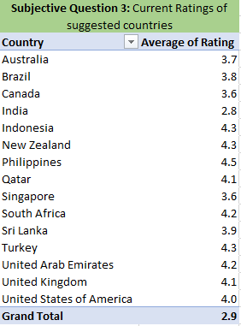

**Inferences:** The top four countries with lower average ratings are suggested because they will tend to have lesser competition as previously mentioned. The average rating of restaurants opened in the suggested countries is 3.69.

1. Also, what is the current expenditure on food in the suggested countries, so we can keep our financial expenditure in control?

**Ans: Analytical approach:**

Created a table named “Current expenditure on food in the suggested countries” and calculated the values using aggregating function “AVERAGEIF”.

**Inferences:**

Visualisation chart in ‘Clustered bar’ and a tabular table shows the expenditure in the targeted country. Clearly visualised Singapore contributes high expenditure among the 4 countries.

**Recommendation:** Since Singapore has the highest food expenditure among the four countries, it's important to focus on managing costs there. Consider strategies like finding cheaper suppliers or optimizing the budget to reduce spending in Singapore while maintaining overall financial control.

Formula: **=AVERAGEIF('Cleaned Data'!E2:E9552,"Canada",'Cleaned Data'!S2:S9552)*'Cleaned Data'!AC7**

**Formula insight:** In the above formula the part **SUMIF ‘Cleaned data’! E:E,”Canada”,’Cleaned data’!S:S** makes a Average of all average cost which are in Canada.

**Location:** Excel file – sheet name – Subjective question 3 & 4 Table - Current expenditure on food in the suggested countries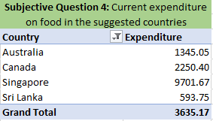.

1. Come up with the names of restaurants from the recommended states that are our biggest competitors and also those that are rated in the lower brackets, i.e. 1-2 or 2-3.

**Ans: Method used:** Created four pivot tables for all the four countries, In the row section Country and restaurant name is there, and in the value field the average of rating is there. On the basis of ratings the competitors are evaluated.

**Inferences:**

* **Restaurants who are biggest competitors:** Are marked in green in the excel. These are biggest competitors as they have highest ratings.
* **Restaurants which are low rated:** This category has been sub divided into two. One which are marked in yellow are the restaurants which are having average ratings. Second category are marked in red are the restaurants which are in the lowest bracket with lowest ratings.

**Recommendation:** Identify top competitors with high ratings marked in green and target them for competitive analysis. For restaurants with lower ratings, focus on those marked in yellow and red. Consider strategies to differentiate your offerings and improve your own ratings to better compete with both high-rated and low-rated establishments.

**Location:** Excel file – sheet name – Subjective question 5 & 6 Table - Names of restaurants from the recommended states that are our biggest competitors

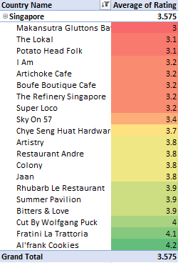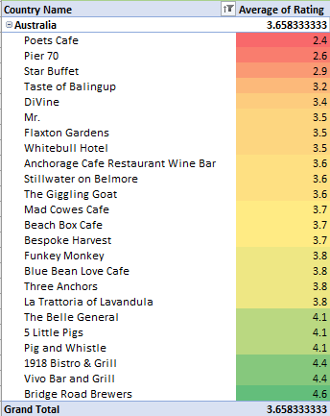

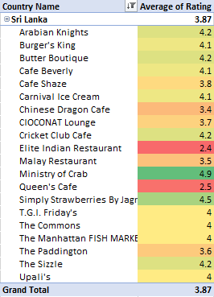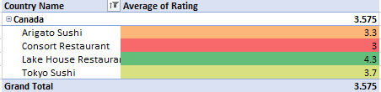

1. Which cuisines should we focus on in the newer restaurants to get better feedback? Does the choice of cuisines affect the restaurant ratings?

**Ans: Cuisines to focus:** Pizza, Italian, Modern Australian, Desert, American, Chinese.

**Inferences:**

* **The choice of cuisines:** Thay affect the ratings as every country has their local food choices and preferences. For example, If you are selling food in other country it would not sell as much as it would sell in Australia
* From the chart below we can consider that most common cuisine of my recommended countries.
* **Australia:** Pizza, Bar food
* **Canada:** Italian, Mediterranean, Pizza
* **Singapore:** Bakery
* **Sri Lanka:** Seafood and Juices, Desserts

**Recommendation:** To boost feedback, align restaurant menus with local tastes: offer Pizza, Italian, and Modern Australian in Australia; Italian, Mediterranean, and Pizza in Canada; Bakery items and Desserts in Singapore; and Seafood, Juices, and Desserts in Sri Lanka. Catering to local preferences improves ratings and satisfaction.

**Location:** Excel file – sheet name – Subjective question 5 & 6 Table - Cuisine Analysis

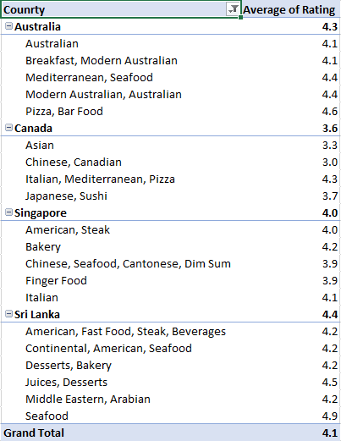

1. According to our current data, should we go for online delivery and table booking? Does that affect the customer’s ratings?

**Ans: Method Used:** I have used COUNTIFS function to calculate the table booking and online delivery for all the country.

**Formula Used: =COUNTIFS('Cleaned Data'!D2:D9552,"Australia",'Cleaned Data'!N2:N9552,"Yes") – For TABLE BOOKING**

**=COUNTIFS('Cleaned Data'!D2:D9552,"Australia",'Cleaned Data'!M2:M9552,"Yes") – FOR ONLINE DELIVERY**

**Inferences:**

* We should go for table booking and online delivery. As none of the restaurants are providing this facility. This can be an edge over our competitors. But for doing this we can go for a survey to know that people in that country are willing to go for online delivery or not.
* Explore if there is a relationship between the cost for two and the availability of table booking or delivery services. Analyse whether customers are willing to pay more for the convenience of these services.

**Recommendation:** Implementing table booking and online delivery could give us a competitive advantage in Australia, as no restaurants currently offer these services. First, conduct a survey to see if customers are interested. Also, analyse the costs and whether customers are willing to pay more for these conveniences.

**Location :** Excel file – sheet name – Subjective question 7 & 8 Table - Delivery Analysis

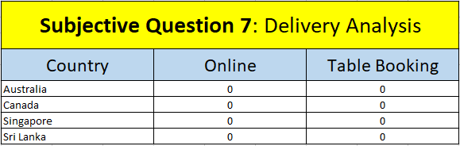

1. Should the team keep the rate of cuisines higher? Will that affect the feedback? According to our data are the rates of cuisines and ratings, correlated?

**Ans: Analytical approach:** I have used CORREL Function to find the correlation between rate of cuisines and ratings**.**

**Inference:** The 0.32 correlation between ratings and average cost indicates a weak positive relationship, meaning higher ratings are only slightly associated with higher costs. Cost changes don't significantly impact ratings.

**Recommendation:** Pricing should focus on market demand and customer preferences rather than expected rating changes. Set competitive prices and offer value through promotions to boost customer satisfaction and engagement.

**Location:** Excel file – sheet name – Subjective question 7 & 8 Table - Relation between cost of cuisines and rate of Cuisines

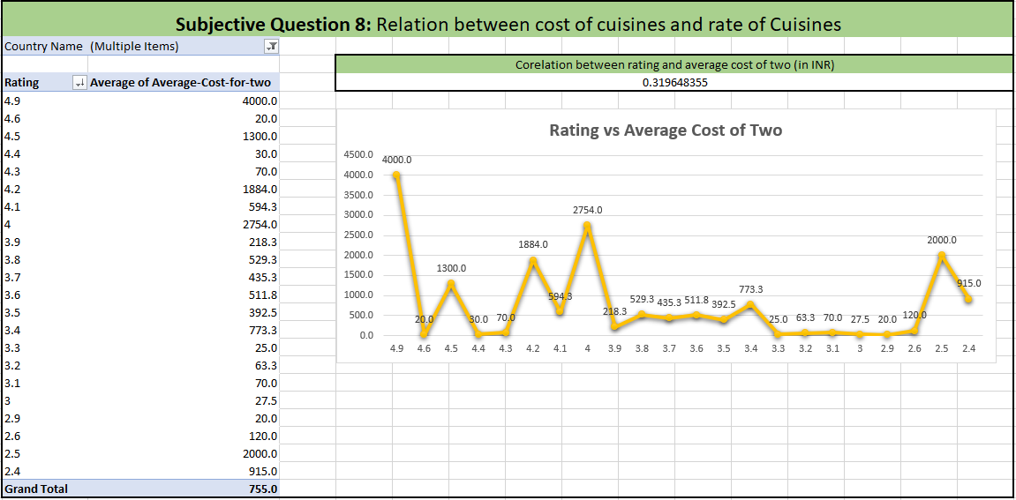

1. What is the distribution of the number of restaurants of different price ranges in all the countries?

**Ans: Method used:** I have used Pivot table, in which rows are price range and value field is count of restaurant ids.

**Inferences:**

* **Price Range 1-2:** The majority of restaurants fall into this category, with **4,444** establishments, indicating that a significant portion of restaurants are more affordable.
* **Price Range 2-3:** This category has **3,113** restaurants, suggesting that mid-range pricing is also quite common, though less so than the lowest price range.
* **Price Range 3-4:** There is a notable drop in the number of restaurants in this range, with only **1,408**, implying that fewer restaurants cater to a higher pricing tier.
* **Price Range 4-5:** The smallest category, with **586** restaurants, shows that only a small percentage of establishments operate at the highest price point.

The data shows that most restaurants are in the lower price ranges, with very few in the higher price ranges. This could be due to what customers prefer, market demand, or economic factors in these countries.

**Recommendation:**

Since most restaurants are in the lower price ranges, focus on offering value and affordability. For higher price ranges, assess if there’s enough demand before expanding, as there are fewer restaurants in these categories.

●      **Visualization method:** Histogram

**Location:** Excel file – sheet name – Subjective question 9 Table - Distribution of the number of restaurants of different price ranges in all the countries

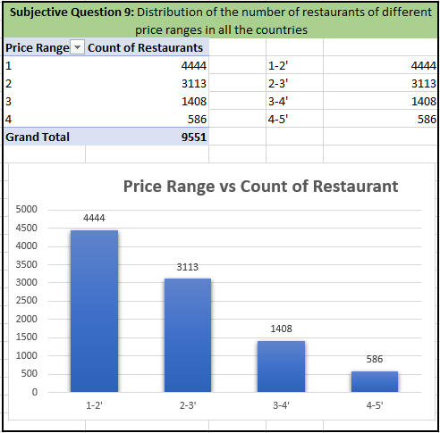

1. Explain your approach in brief for suggesting countries/cities in order to open new restaurants, if the objective and subjective questions would have not been given to assist you. **[you have to give bullet pointers in order to answer this question]**

**Ans: Countries Suggested:** (Australia, Canada, Singapore, Sri Lanka)

**Analytical Criteria:**

* Utilized Pivot tables with restaurant count and average ratings.
* Applied filters for low competition and ratings below 4.

**Strategic Insights:**

* Identified regions with both low competition and potential for improvement in average ratings.
* Focused on countries where market entry could yield substantial benefits.

**City Selection:**

**Analytical Criteria:**

* Employed similar Pivot table approach on city-level data.
* Focused on cities within suggested countries with low competition and ratings less than 4.

**Strategic Insights:**

* Choose cities aligning with the overall country criteria.
* Aimed for a balanced selection of cities within the recommended countries based on data analysis.